**Outline of core logic architecture**

* **plrankcalc**

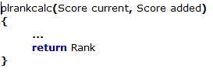

This will take the current users score, and the new score and return the rank of the player. Problem is, where will the threshold for ranks be stored? Should it be hard coded into the function, somewhere else? Loaded from a text file?

* **Checkrank**

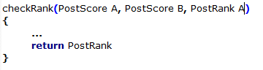

The idea is that a posts rank will determine where it is on the front page. Every so many minutes, posts will check their score compared to those 1 rank higher than them, or when they have been voted on. If the post A, has a higher score than post B, it will return the new rank. Otherwise it will return the old rank.

(Need to discuss how will the ranks change, what kind of logic should be used)

* **addscore**

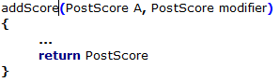

This will be used to modify a posts score, by either adding 1 for if it’s a vote, or for adding or subtracting a certain amount to the score. Will do checks to make sure that the score is not going out of bounds.

* **Getpostchildren**

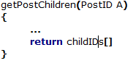

This will retrieve all the IDs of answers to a question post and return that information as an array. (Not sure how to deal with time of answer sorting, maybe happens later on? Will it not matter due to the database?)

* **Getpostowner**

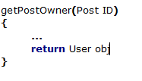

This will get information on the user who posted the specific post.

* **checkPostTime**

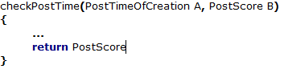

This will compare the posts time of creation to the current time and then determine how long the post has been there. Depending on its age the posts score will go down by a certain amount. The exact formula for this is yet to be determined.